NEW SERVICE!!
Mobile Printing Now Available

With our new MobilePrint Service™, you can use your personal computer or mobile device to print to the library’s printers from anywhere. Simply submit documents for printing and come to the Honey Harbour Library to pick up your print job.

How to print from a laptop or desktop computer at home or work:

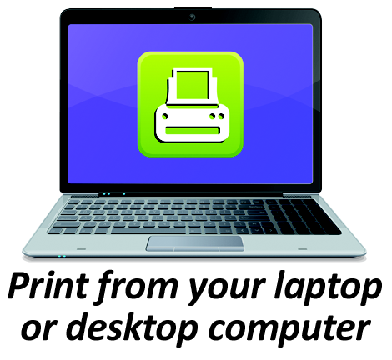
- Begin by visiting http://www.printeron.net/gbpl/honeyharbour
- Select the printer and enter your email address.
- Browse your computer to find and select the file you wish to print.
- Click the green print icon (you will see the status of your print job and a reference number).
- Come to the library during open hours to pick up your document.
- At the checkout desk let the clerk know the email address used for the print item.

The clerk will release the item and for a nominal fee your document will be printed!

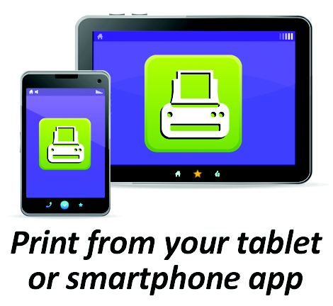
How to print from tablet or smartphone app:

- Visit your device’s ‘store’ for apps, install and launch the PrinterOn App.
- Click “No printer selected”.
- Click “Search”. Search for Honey.
- Find Georgian Bay Public Library Honey and choose the Black and White Printer or the Colour Printer.
- To print:
  - Documents: when viewing the document, click in the upper right corner and upload the document to the PrinterOn App.
  - Photos from your phone: open the app, click on “photo” and select a photo to print.
  - Select the printer and click the print icon.
  - Enter an email address and click on the check mark (you will receive a notice that the job started, and shortly after another message stating “Job Success”).
  - Come to the library during open hours to pick up your document.
  - At the checkout desk let the clerk know the email address used for the print item.

The clerk will release the item and for a nominal fee your document will be printed!

How to use email to send something directly to library print system:
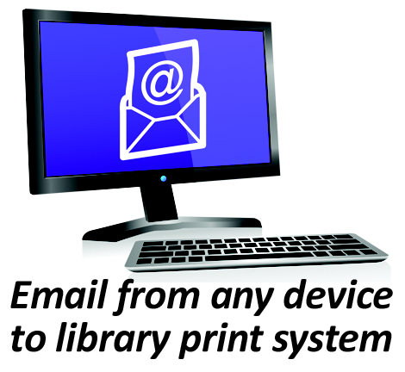
- Email from any device directly to the library’s print system at
gbpl-mainlibrary-bw@printspots.com for black and white or
gbpl-mainlibrary-colour@printspots.com for colour printing.
- Come to the library during open hours to pick up your document.
- At the checkout desk let the clerk know the email address used for
- the print item.

The clerk will release the item and for a nominal fee your document will be printed!

